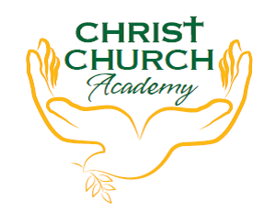

Join us for the

**Harvest Assembly**

Wednesday 20th October

9am in the Hall

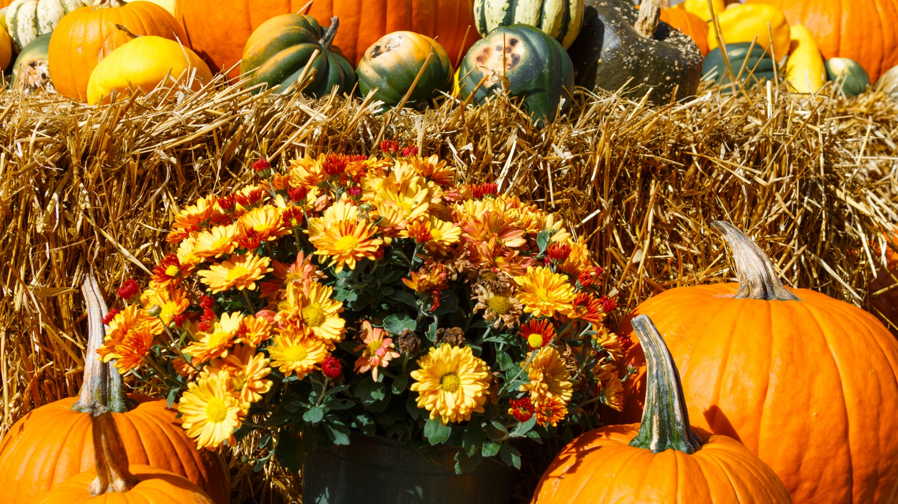

We would like to donate to Bradford North foodbank. There is a real shortage of specific items which we would like to collect. Please see our list below.

**Tinned Ham or Chicken Sugar**

**Tinned tomatoes Biscuits**

**Bars of chocolate UHT Milk**

**Crisps/savoury snacks Toothbrushes/toothpaste**